Online Shopping System: FootFusion

Use-Case-Realization Specification: Add Products

Version <1.0>

Revision History
Date | Version | Description | Author
23/11/2024 | 1.0 | Final Draft | Dao Ngoc Quang

Table of Contents
1. Introduction 4
1.1 Purpose 4
1.2 Scope 4
1.3 Definitions, Acronyms, and Abbreviations 4
1.4 References 4
1.5 Overview 4
2. Flow of Events—Design 4
3. Derived Requirements 5

Use-Case-Realization Specification: Add Products

Introduction

Purpose

This document explains how the Add Products Use-Case is implemented within the design model, focusing on the collaboration of various objects.

Scope

This document applies to the FootFusion platform, a shoe-selling website under development.

Definitions, Acronyms and Abbreviations
Buyer: An individual using the FootFusion website to purchase footwear.

References
Use Case Specification – Add Products

Overview
The following sections detail the Use-Case Realization Specification for the Add Products Use-Case within FootFusion. The Flow of Events section includes a sequence diagram illustrating the use-case realization through collaborating objects and a class diagram showcasing the relationships between participating entities. The Derived Requirements section outlines additional requirements, including non-functional ones, not fully addressed in the design model but essential for implementation.

Flow of Events—Design
Buyers can add a new product to their cart within the FootFusion system.

Sequence diagram

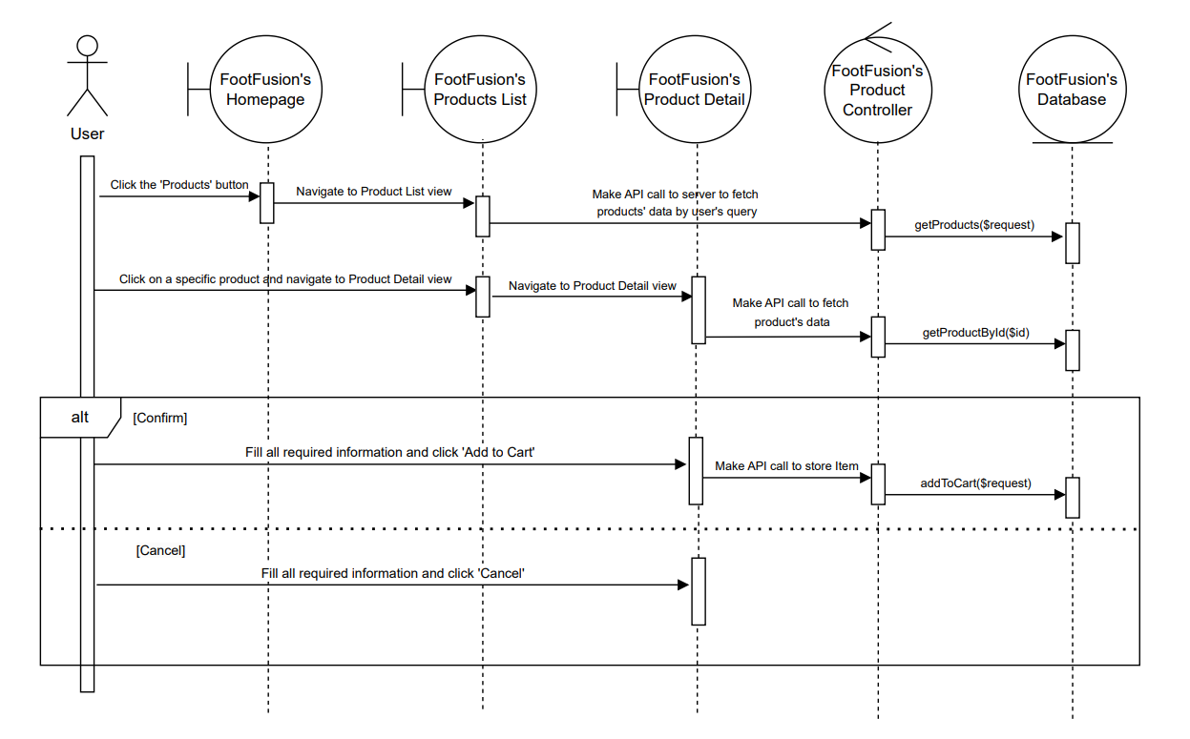

Class diagram
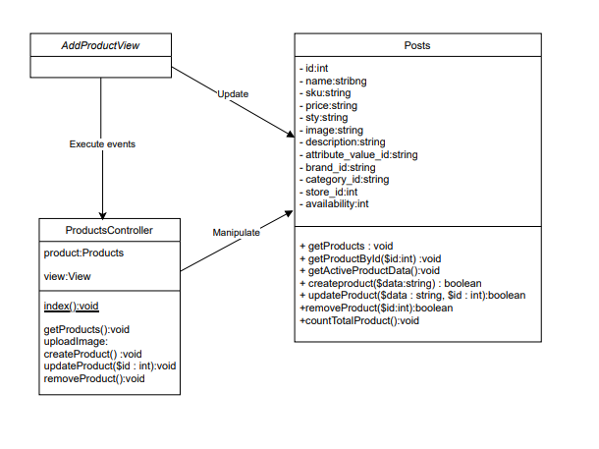

Derived Requirements
There is no derived requirement.

